Task 2: Frontend Form with MongoDB Atlas
- Create a form on the frontend that, when submitted, inserts data into MongoDB Atlas.
- On success: the user should be redirected to another page displaying the message “Data submitted successfully”.
- On error: display the error on the same page without redirection.

ANS :
Create a form on the frontend
created a frontend using html and css student_form.html. Created two forms for submiting the data and for viewiing the data.
On submit action calling the POST method for saving the student info and GET method for viewing the student info.

Mongo DB
created mongo DB on Atlas. Databse name is tutedude_assignments and created collections Student.

Student_db.py
keeping the saperate file to connect the database. Implemented the class Student so can reuse the database connection and methods.

using the dotenv loaded the enviornment variables mentioned in .env file.
Was getting the error for database password so parsed it using quote_plus() and created the database string url to authnticate.
Now connected to the database using MongoClient
and created the two function to save and get data from database. insert_one() is used to insert a data into database and find() is used to get the data from database. It’s returns the cursor object so cleaned the data using for loop and created another list.

Flask API
imported the Flask and render_template and Students and json

on route “/” returned the student_form.html file.

And on route /Students specified the two methods and separating it using the http methods. If POST call comes to Flask then it’s triggers the save_student_info() and if GET call received then list_student_info() get called

list_student_info():
intialized the Student class object to access database and using get_data() of student object fetching all the info and returning the data.

save_student_info()
executing it if only POST call triggered. Fetching the student name and grades using the request.form object. And checking the validation if student is already exist or not. If exist then giving an error on same page using the Jinja. And validating grades if grades are valid or not. If all validations are passed then inserting the data into database using insert() of Student object and returning the success message.

Created the Cluster and database on Atlas:

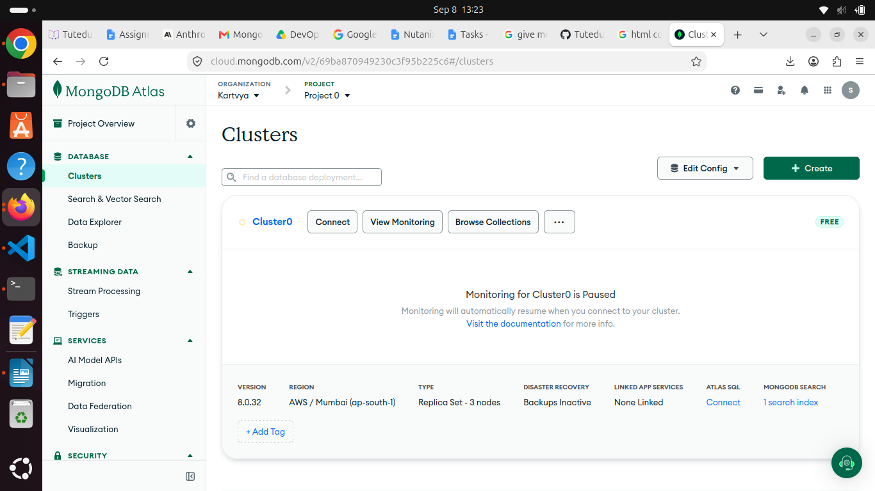

Cluster connection string to connect database :

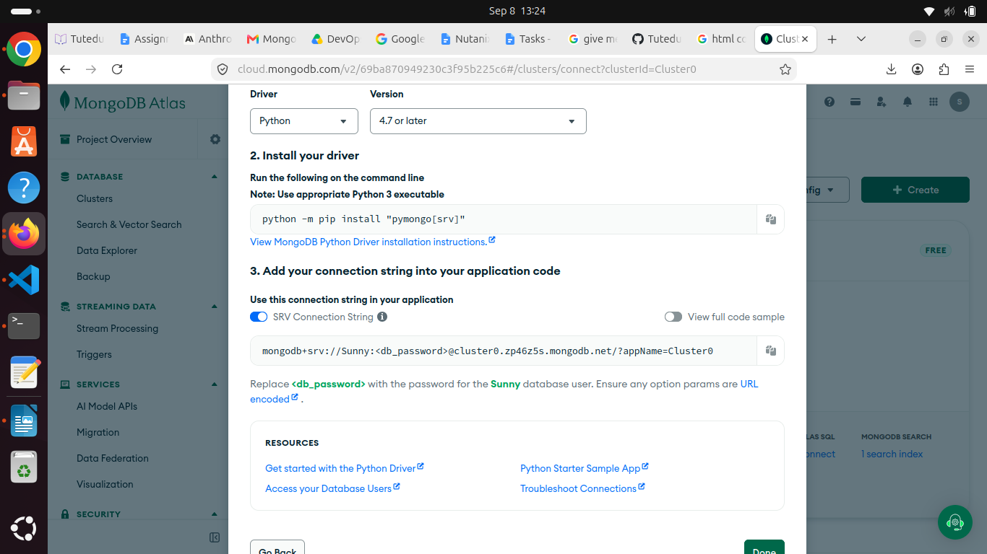

Created the database users :

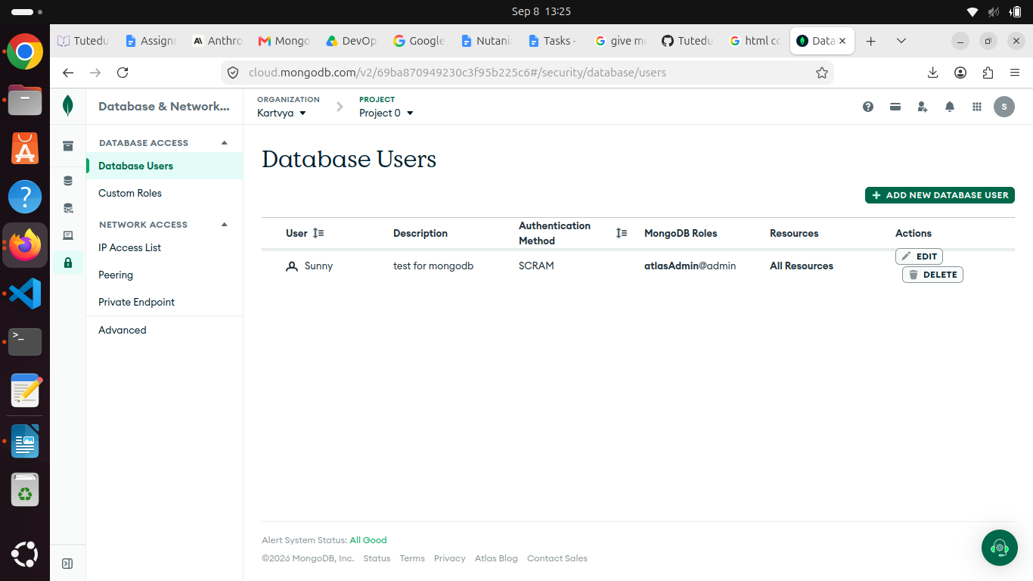

added default network 0.0.0.0/0 to get accessed by everyone

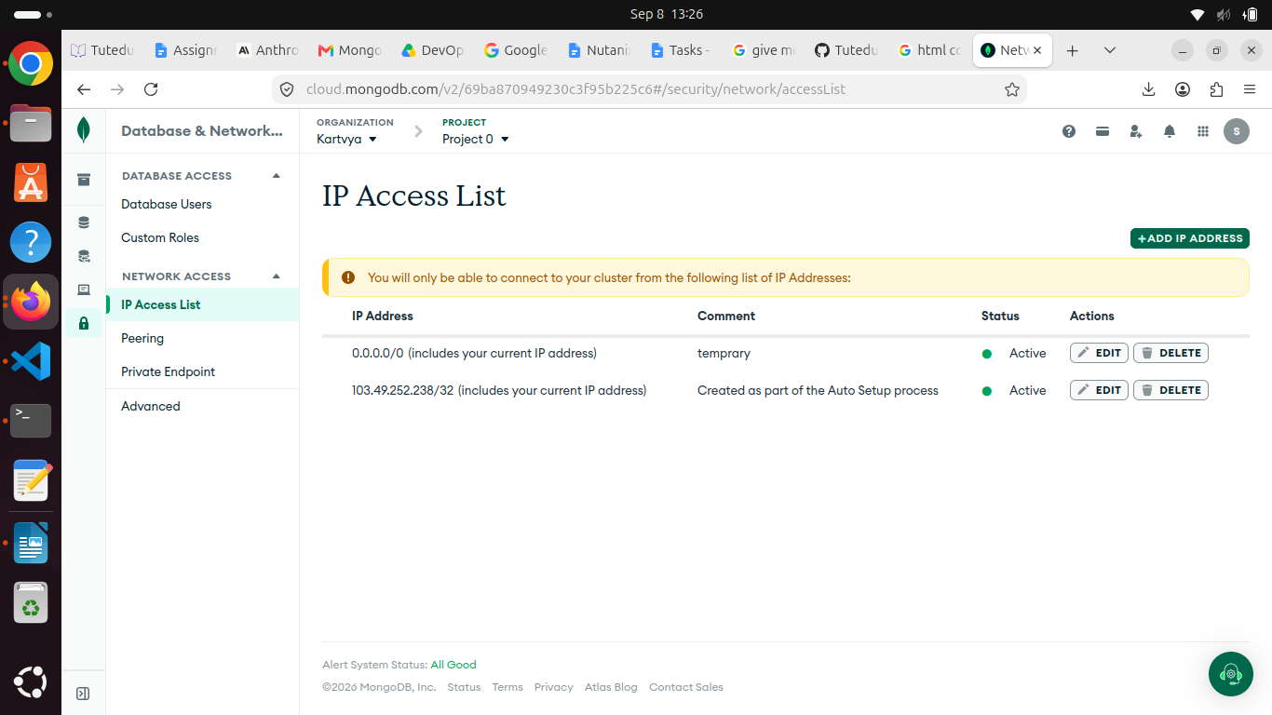

Running an Flask application

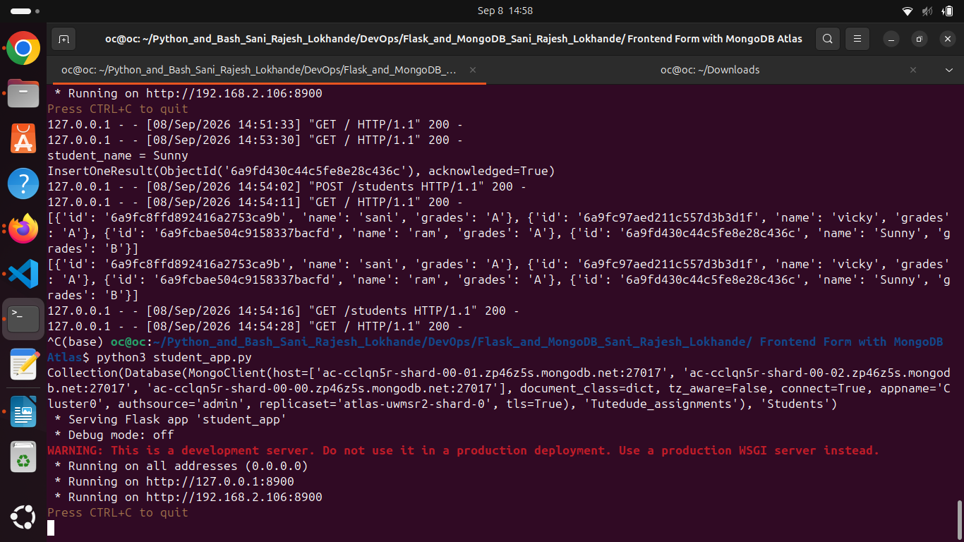

UI page running on port 8900

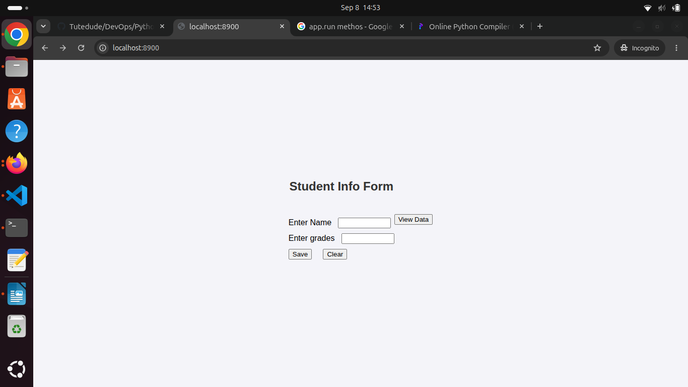

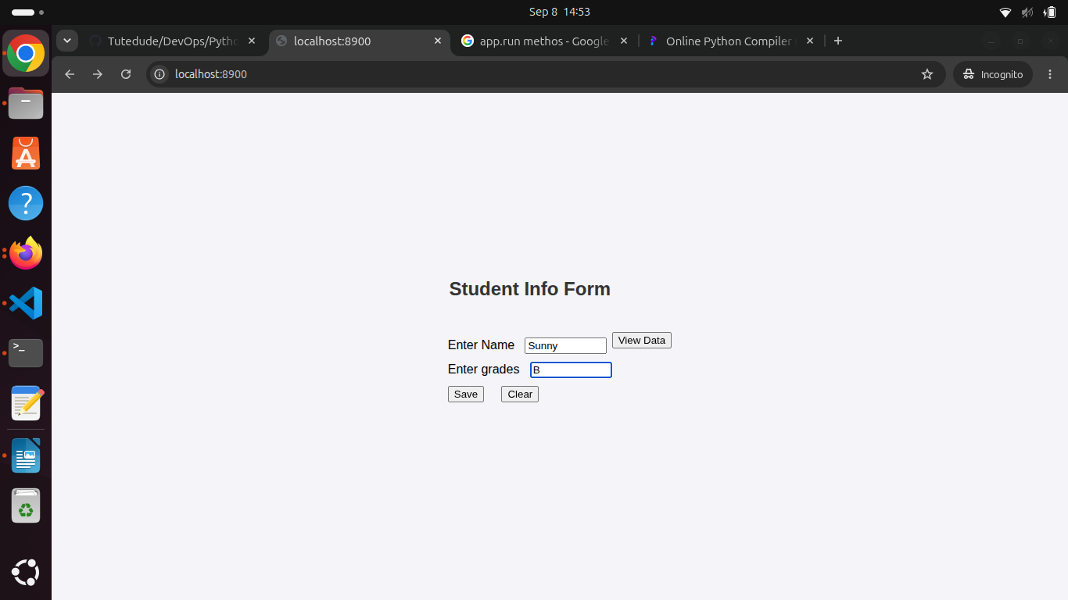

after submitting the student data

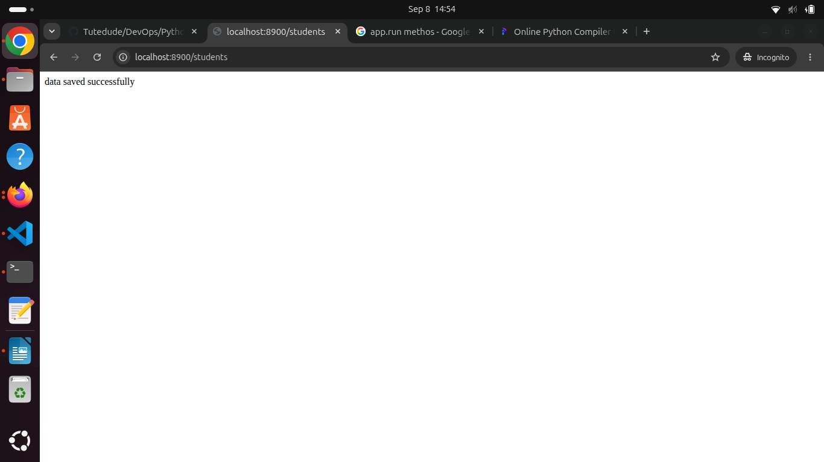

printed the newly added student into the database
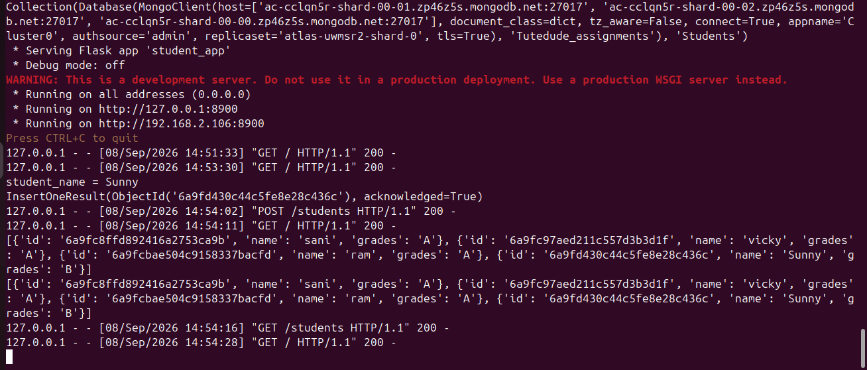

Entries got updated in Atlas :

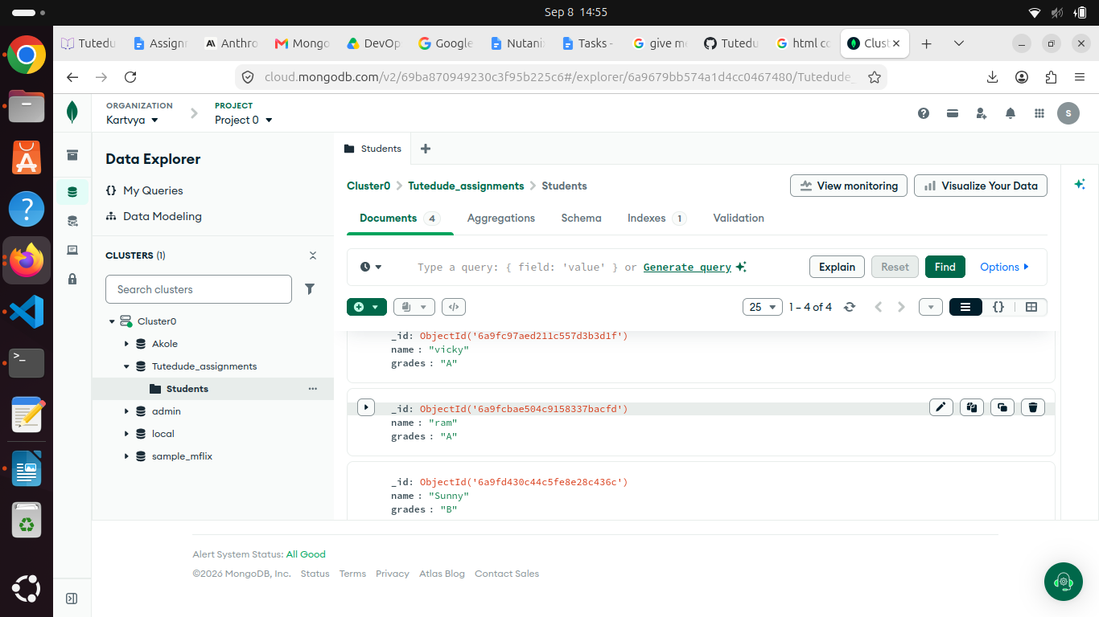

after clicking on view data :

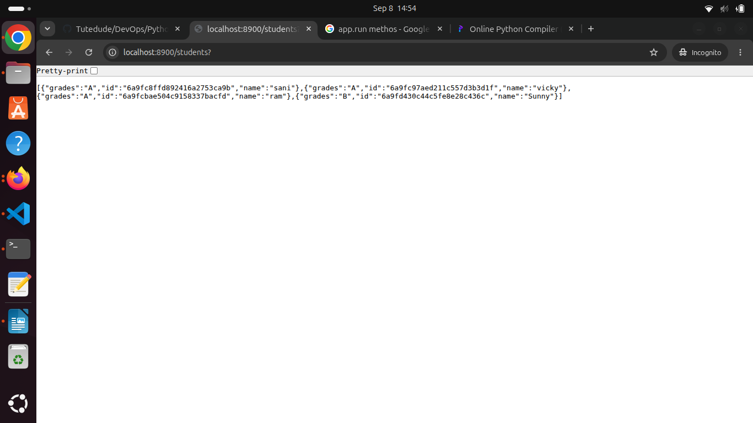

error messages using Jinja on same page if data entered incorrectly

if name is already present

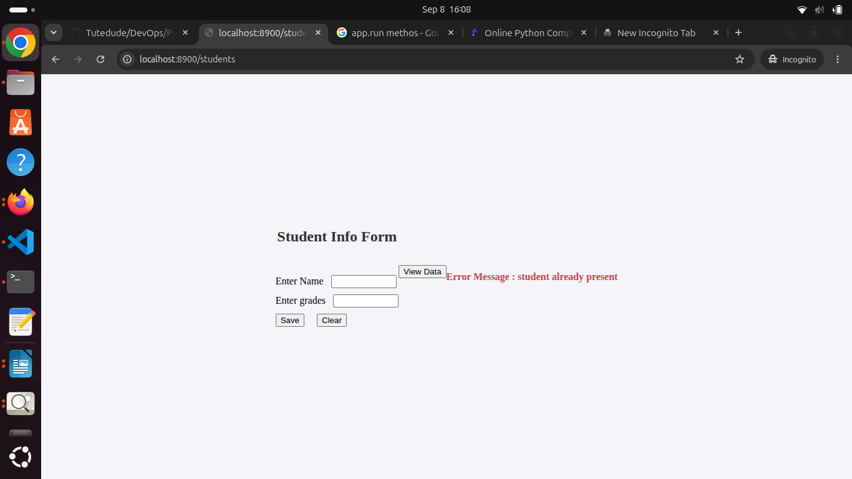

if invalid grades entered :

